Submission Date: | 07/15/2014

IS 250 Project Submission Report

Fill in your Last and First Name in Solution Folder Name. Make sure that you submit Solution Folder with this Word document inside it, not only this document. You can also submit a zipped copy of your Solution folder.

Solution Folder Name:

P3_Bhandari_Ananta

Solution folder name must be given in the following format:
P3_LastName_FirstName Example: P3_Norton_Peter
Project Documentation: Your program should be internally documented. Documentation includes:
- Header that must be placed at the top of the main source code module, with your name, date, purpose of the program. Example:
‘ Peter Norton
’ IS 250, Project 3: Running the Race
’ Project started: 7/10/2014, Project Submitted: 7/15/2014
’ Purpose of the program: …

- Remarks inside your code: purpose of all procedures, comments on variables and algorithm;
Try to comment almost every line!
- Controls and Variables Names: should all be mnemonic and follow Hungarian notation
(3 letter prefix low case, SentenceCaseNoSpaces). For Example: lblGrossDomesticProduct
- Work progress time log: You must keep track of each important step of the development / debugging process (like adding a new feature, error correction, or major modification to the project) with a short description of what has been done and the date/time stamp of each step.
Example:
Student Name Project 2: States Information Program
Work Planning | Implementation Notes | Time Date:
Started to work on the project | Got tutor Matt to help | 8:00am 6/27/2014
Designed project specifications and GUI prototype | Alignment of picture boxes was an issue | 11:30am
Interface development: created controls |  | 12:05pm
Programmed event procedures | Used … property in order to | 5:50pm
… | … | 9:50pm
Corrected errors | Used breakpoints to find errors in … | 2:33am 7/29/2014
Improved layout form…. | Adjusted …. | 3:30 am
…
Submitted Solution for Grading | Most challenging in project was… Learned… | 3:00pm 8/3/2014

Completed projects must be dropped in CourseFiles Y: drive before class on the due date.
Make sure that you copy and drop the Solution Folder into the Assignment Drop Box and not move it, so that you won’t lose your copy of your project.
Each project submission should include the following:
❑ Solution Folder with all necessary files to compile and run the application
❑ This Submission Report as a word document inside root of the Submission Folder
❑ Include a copy of the source code of your application with header information (see above)
at the end of this .doc file: grader may add comments to this source code if needed.
❑ Include screen shots of all forms in run time, demonstrating how the program works (both inputs and outputs). Use Alt-PrintSreen to copy an active Window to Clipboard. You can put several windows forms in this Word document, adding necessary comments.
❑ Program documentation (as required above)
❑ Any relevant paperwork (draft design charts and scketches, notes, etc), demonstrating your work
progress can be scanned/photographed and attached to this document.

The project is considered not submitted until the Solution Folder with this Report can be found in the
Assignment Drop Box in Course Files (Y:/ drive)!

The penalty for late programs is 25% of total points off for each day late.
IS 250: Individual Project 3
Chapters 2-4 Assignment
Chapter 4: Programming Challenge #4, p.279
Running the Race
Project Description:
- This project is a programming challenge found at the end of the chapter
- Submit this Report inside your Solution Folder
- Sample Solution (.exe) can be found on Y: Course Files
- Download clip art/images from the web or make/modify your own using Paint or other tools

❑ (10 points) Basic Design
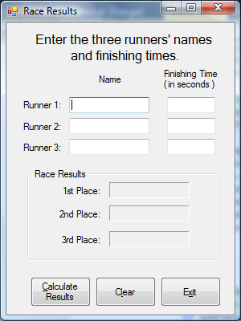
Your initial Form design is available at the end of the chapter next to programming challenge #4 Running the Race. You may change the design of the form to match the type of contest or to be creative.
- Validate all user input
- Sort the input to determine place
- Format all output appropriately using .ToString method
- Use a Group Box as shown on the Demo Solution

Private Sub Pedestal()
Dim frmRacePedestal As New frmPedestal
With frmRacePedestal
.lblFirst.Text =
.lblSecond.Text =
.lblThird.Text =
.ShowDialog()
End With
End Sub

❑ (5 Points) Pedestal Form
Extend your form to display the results
graphically. See sample pedestal with
trophy pictures in Demo solution, but you are welcome to suggest your own design.
- Appropriate trophy (or athlete…) picture should be displayed on the correct tier
- Names should be displayed properly under the correct trophy
- You can either:
  - make a new form (see more on multiple forms in Chapter 7, if needed), then use the code in the textbox above to call the new form. Form must be named frmPedestal, and use the lbl names listed above, or change them to match your labels,
  - or design your graphics on the main form (similarly to Project 2 by varying form’s .Width property)
❑ (5 points) Program Documentation
Follow naming conventions and provide documentation as required (see above)
Overall 20 Points Possible
❑ (up to 5 extra points) Extended Version: Accounting for tie results
Modify your application so it can accept same results for 2, or all 3 athletes.
Copy and paste all your Source Code here:

' Ananta Bhandari
' IS 250, Project 2: States Information Program
' Project started: 07/12/2014, Project Submitted: 07/15/2014
' Purpose of the program: The purpose of this application is to choose the winner by comparing their
'respective finishing time for the race. Upon execution the program should open another form where it
'places the respective runner on pedestal depending on their Race Status. The program also places the runner on
'pedestal if they have same finishing time.

Option Strict On

Public Class frmRaceResults

Private Sub btnCalculateResults_Click(sender As System.Object, e As System.EventArgs) Handles btnCalculateResults.Click

'capture input
Dim strRunner1 As String = txtRunner1.Text
Dim strRunner2 As String = txtRunner2.Text
Dim strRunner3 As String = txtRunner3.Text

'declare a variable
Dim dblRunnerTime1, dblRunnerTime2, dblRunnerTime3 As Double

'Validating the name is entered for Runner 1
If strRunner1 = String.Empty Then

'Shows error if the label is empty
MessageBox.Show("Please Give a name of Runner1. The name cannot be blank")
txtRunner1.BackColor = Color.LightBlue ' The text box changes Color
txtRunner1.Focus()
Exit Sub
Else
'Validating the name is entered for Runner 2
If strRunner2 = String.Empty Then

'Shows error if the label is empty
MessageBox.Show("Please Give a name of Runner2. The name cannot be blank")
txtRunner2.BackColor = Color.LightBlue ' The text box changes Color
txtRunner2.Focus()
Exit Sub
Else
'Validating the name is entered for Runner 3
If strRunner3 = String.Empty Then

'Shows error if the label is empty
MessageBox.Show("Please Give a name of Runner3. The name cannot be blank")
txtRunner3.BackColor = Color.LightBlue ' The text box changes Color
txtRunner3.Focus()
Exit Sub
End If
End If
End If

'Validate the users enters the numeric values for time
'Validate the Runner 1 time is valid
If Not Double.TryParse(txtRunner1Time.Text, dblRunnerTime1) Then

'Show message box to enter valid numeric value
MessageBox.Show("Please enter time for runner 1")
txtRunner1Time.BackColor = Color.LightBlue ' The text box changes Color
txtRunner1Time.Focus() ' move the focus back to runner 1 time
Exit Sub
ElseIf dblRunnerTime1 <= 0 Or dblRunnerTime1 > 20 Then

'Show message box to enter valid numeric value
MessageBox.Show("Please enter the positive number for runner 1 between 1 and 20")
txtRunner1Time.BackColor = Color.LightBlue ' The text box changes Color
txtRunner1Time.Focus() ' move the focus back to runner 1 time
Exit Sub
Else
'Validate the Runner 2 time is valid
If Not Double.TryParse(txtRunner2Time.Text, dblRunnerTime2) Then

'Show message box to enter valid numeric value
MessageBox.Show("Please enter time for runner2")
txtRunner2Time.BackColor = Color.LightBlue ' The text box changes Color
txtRunner2Time.Focus() ' move the focus back to runner 2 time
Exit Sub
ElseIf dblRunnerTime2 <= 0 Or dblRunnerTime2 > 20 Then

MessageBox.Show("Please enter the positive number for runner 2")
txtRunner2Time.BackColor = Color.LightBlue ' The text box changes Color
txtRunner2Time.Focus() ' move the focus back to runner 2 time
Exit Sub
Else
'Validate the Runner 3 time is valid
If Not Double.TryParse(txtRunner3Time.Text, dblRunnerTime3) Then
'Show message box to enter valid numeric value
MessageBox.Show("Please enter time for runner3")
txtRunner3Time.BackColor = Color.LightBlue ' The text box changes Color
txtRunner3Time.Focus() ' move the focus back to runner 3 time
Exit Sub
ElseIf dblRunnerTime3 <= 0 Or dblRunnerTime3 > 20 Then
txtRunner3Time.BackColor = Color.LightBlue ' The text box changes Color
MessageBox.Show("Please enter the positive number for runner3")
txtRunner3Time.BackColor = Color.LightBlue ' The text box changes Color
txtRunner3Time.Focus() ' move the focus back to runner 3 time
Exit Sub
End If
End If
End If

' Determine if Runner 1 has the best time
If (dblRunnerTime1 < dblRunnerTime2) And (dblRunnerTime2 < dblRunnerTime3) Then
lbl1stPlace.Text = strRunner1
lbl2ndPlace.Text = strRunner2
lbl3rdPlace.Text = strRunner3

'Determine if 3rd runner has second best time with 1st runner being best
ElseIf (dblRunnerTime1 < dblRunnerTime2) And (dblRunnerTime3 < dblRunnerTime2) Then
lbl1stPlace.Text = strRunner1
lbl2ndPlace.Text = strRunner3
lbl3rdPlace.Text = strRunner2

' Determine if Runner 2 has the best time
ElseIf (dblRunnerTime2 < dblRunnerTime1) And (dblRunnerTime1 < dblRunnerTime3) Then
lbl1stPlace.Text = strRunner2
lbl2ndPlace.Text = strRunner1
lbl3rdPlace.Text = strRunner3

'Determine if 3rd runner has second best time with 2nd runner being best
ElseIf (dblRunnerTime2 < dblRunnerTime3) And (dblRunnerTime3 < dblRunnerTime1) Then
lbl1stPlace.Text = strRunner2
lbl2ndPlace.Text = strRunner3
lbl3rdPlace.Text = strRunner1

' Determine if Runner 3 has the best time
ElseIf (dblRunnerTime3 < dblRunnerTime2) And (dblRunnerTime2 < dblRunnerTime1) Then
lbl1stPlace.Text = strRunner3
lbl2ndPlace.Text = strRunner2
lbl3rdPlace.Text = strRunner1

' Determine if Runner 3 has the best time with 1st runner as 2nd best
ElseIf (dblRunnerTime3 < dblRunnerTime1) And (dblRunnerTime1 < dblRunnerTime2) Then
lbl1stPlace.Text = strRunner3
lbl2ndPlace.Text = strRunner1
lbl3rdPlace.Text = strRunner2

' Determine if there is a tie among racers
'Determine if all other racers are tied
ElseIf (dblRunnerTime1 = dblRunnerTime2) And (dblRunnerTime1 = dblRunnerTime3) Then

lbl1stPlace.Text = strRunner1 & " And " & strRunner2 & " And " & strRunner3
lbl2ndPlace.Text = "WOW there is a tie"
lbl3rdPlace.Text = "Wow there is a tie"

'Tie for first place between runner1 and runner 2
ElseIf (dblRunnerTime1 = dblRunnerTime2) And (dblRunnerTime2 < dblRunnerTime3) Then

lbl1stPlace.Text = strRunner1 & " And " & strRunner2
lbl2ndPlace.Text = strRunner3
lbl3rdPlace.Text = "WOW there is a tie"

'Tie for first place between runner1 and runner 3
ElseIf (dblRunnerTime1 = dblRunnerTime3) And (dblRunnerTime3 < dblRunnerTime2) Then

lbl1stPlace.Text = strRunner1 & " And " & strRunner3
lbl2ndPlace.Text = strRunner2
lbl3rdPlace.Text = "WOW there is a tie"

'Tie for first place between runner2 and runner 3
ElseIf (dblRunnerTime2 = dblRunnerTime3) And (dblRunnerTime2 < dblRunnerTime1) Then

lbl1stPlace.Text = strRunner2 & " And " & strRunner3
lbl2ndPlace.Text = strRunner1
lbl3rdPlace.Text = "WOW there is a tie"

'Tie for second place between runner1 and runner 2
ElseIf (dblRunnerTime3 < dblRunnerTime2) And (dblRunnerTime2 = dblRunnerTime1) Then

lbl1stPlace.Text = strRunner3
lbl2ndPlace.Text = strRunner2 & " And " & strRunner1
lbl3rdPlace.Text = "WOW there is a tie"

'Tie for second place between runner2 and runner 3
ElseIf (dblRunnerTime1 < dblRunnerTime2) And (dblRunnerTime2 = dblRunnerTime3) Then

lbl1stPlace.Text = strRunner1
lbl2ndPlace.Text = strRunner2 & " And " & strRunner3
lbl3rdPlace.Text = "WOW there is a tie"

'Tie for second place between runner1 and runner 3
ElseIf (dblRunnerTime2 < dblRunnerTime1) And (dblRunnerTime1 = dblRunnerTime3) Then

lbl1stPlace.Text = strRunner2
lbl2ndPlace.Text = strRunner1 & " And " & strRunner3
lbl3rdPlace.Text = "WOW there is a tie"
End If

Pedestal()
End Sub
Private Sub Pedestal()
Dim frmRacePedestal As New frmPedestal
With frmRacePedestal

.lblGold.Text = lbl1stPlace.Text
.lblSilver.Text = lbl2ndPlace.Text
.lblBronze.Text = lbl3rdPlace.Text

.ShowDialog()
End With
End Sub

Private Sub btnClear_Click(sender As System.Object, e As System.EventArgs) Handles btnClear.Click
'Clear all the values
txtRunner1.Text = String.Empty ' clears value for runner 1
txtRunner2.Text = String.Empty ' clears value for runner 2
txtRunner3.Text = String.Empty ' clears value for runner 3
txtRunner1Time.Text = String.Empty ' clears value for runner1 time
txtRunner2Time.Text = String.Empty ' clears value for runner2 time
txtRunner3Time.Text = String.Empty ' clears value for runner3 time
lbl1stPlace.Text = String.Empty ' clears value for 1st place
lbl2ndPlace.Text = String.Empty ' clears value for 2nd place
lbl3rdPlace.Text = String.Empty ' clears value for 3rd place
'Give focus to Runner 1
txtRunner1.Focus() ' move the focus back to Runner 1
AllTextBoxesWhite() ' calling a procedure to clear back color
End Sub
Sub AllTextBoxesWhite()
'all txtboxes are white to begin with
txtRunner1.BackColor = Color.White
txtRunner2.BackColor = Color.White
txtRunner3.BackColor = Color.White
txtRunner1Time.BackColor = Color.White
txtRunner2Time.BackColor = Color.White
txtRunner3Time.BackColor = Color.White
End Sub

Private Sub btnExit_Click(sender As System.Object, e As System.EventArgs) Handles btnExit.Click
'Close the form
Me.Close()
End Sub
End Class
Copy all your Windows forms (using Alt-PrntScrn) at run-time and paste here with comments as needed.

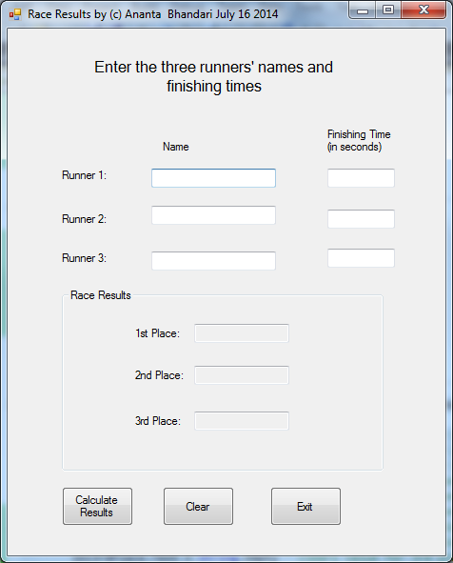

Screen Shot1: Initial Start of Application

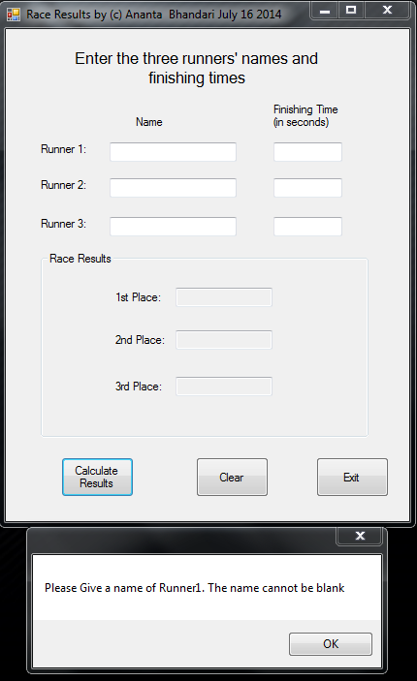

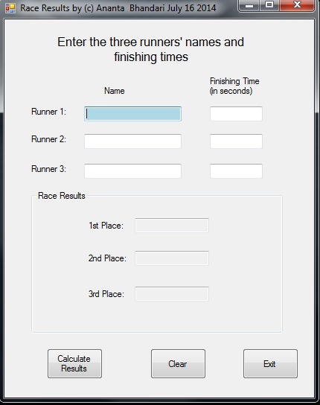

Screen Shot 2: Gives error for not entering runner name. Focus also moves back to the respective runner. In this case focus moved back to Runner 1. Label will also change the color.

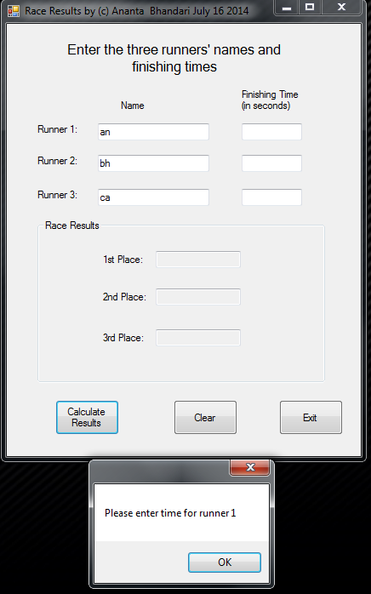
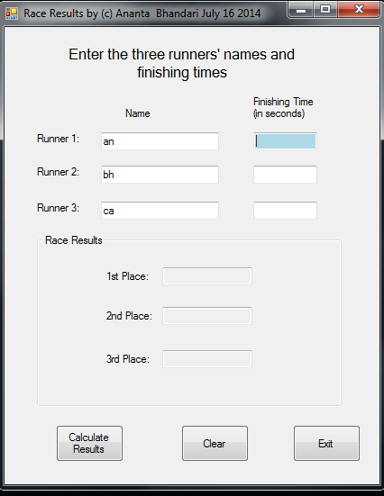

Screen Shot 3: Gives error for not entering runner1 time. Focus also moves back to the respective runner and changes the label color.

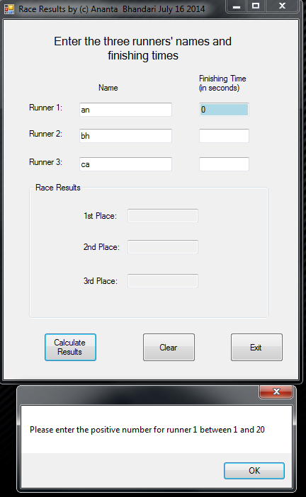

Screen Shot 4: Prompts error for not entering number between 1 and 20.

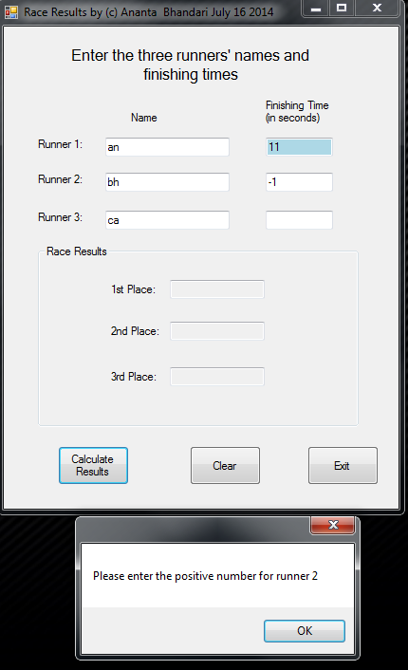

Screen Shot 5: Prompts error for entering negative value.

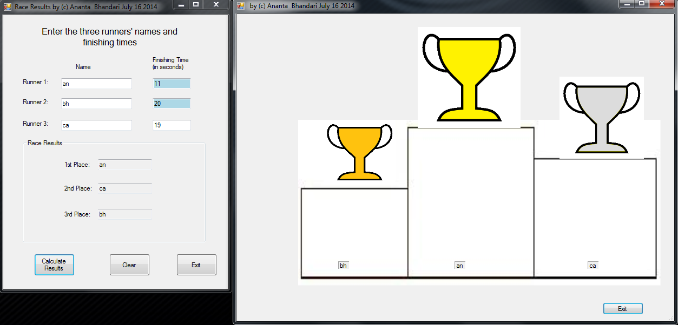

Screen shot 6 : Places the runner on pedestal. Upon exiting the pedestal. The time can be verified from initial start screen of program.

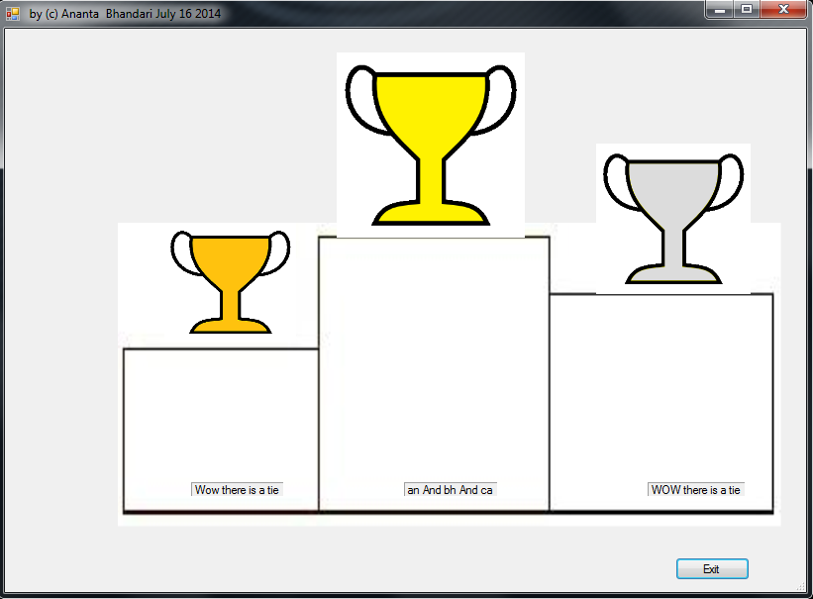

Screen Shot 7: If all runner ties.
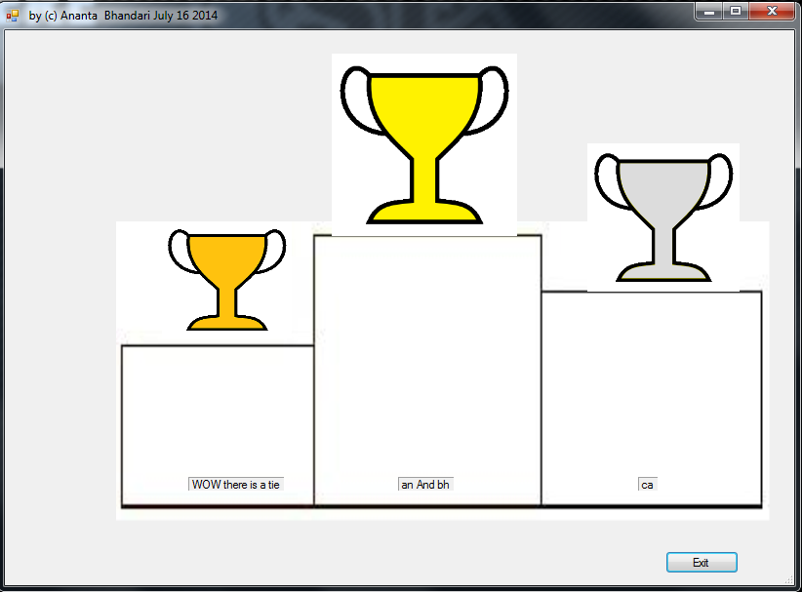

Screen Shot 8 : If two runner ties for 1st place.

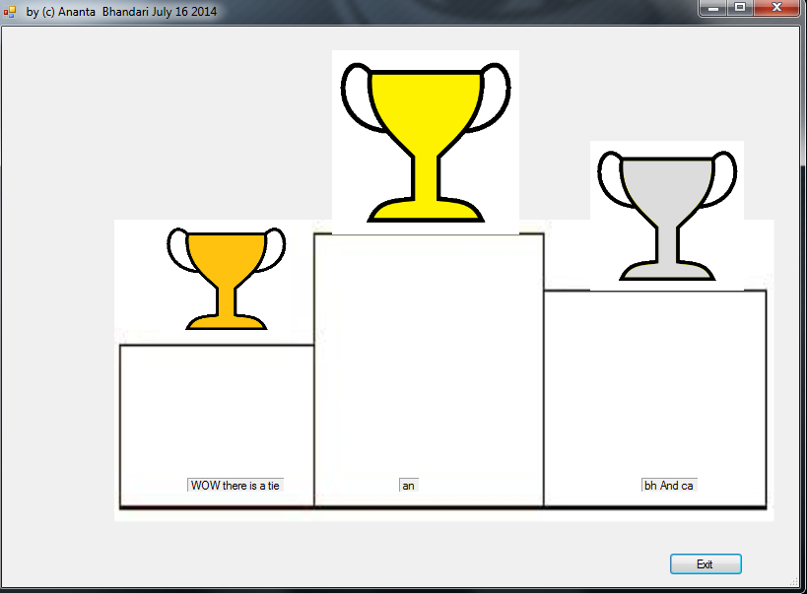

Screen Shot 8: if 2 runner ties for 2nd place.

Note: Clicking on clear will clear all the values.

Ananta Bhandari Project 3: States Information Program
Work Planning | Implementation Notes | Time Date:
Identified the execution method  Made a Blue Print for GUI  Created Labels, Textboxes, Picture boxes for pedestals and trophy  Renamed all the labels  Started to code for the Project  Programmed using If then else statement to make sure all the runner name and times were valid.  Used if then else statement to check who won.  Debug using break point  Re worked on my logical expression  I used breakpoint to execute one expression at a time  Ran the Program  Submitted for Grading  Reworked on design and tried to make my code clean and well commented  Resubmitted for grading | Aligned labels and picture boxes properly  Used proper naming convention  Used dim to declare a variable  Had a problem with the logical argument  Still had problems showing name of winner  I found that I was using wrong label for logical expression on few occasions. Corrected all the errors  Checked the entire runner with different values. The application was working.  Making If then Else work was very challenging. | 9:00 am 07/12/2014  9:20 am  9:30 am  9:35 am  9:45 am  12:00 pm 07/14/2014  3:30 pm  7 pm  11:30 am 07/15/2014  1:15 pm  1:40pm  12:00 pm 07/16/2014
 |  | 2:00 pm

